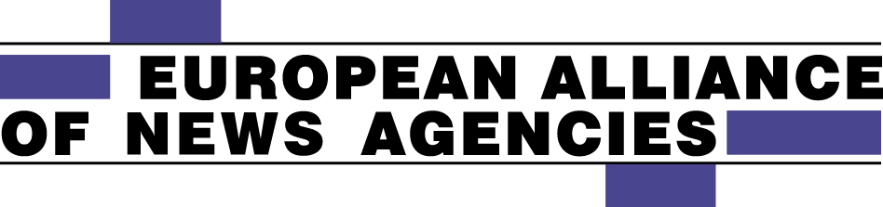

SECRETARIAT
Erik Nylén
Norrtullsgatan 5, 113 29 Stockholm- Sweden
Tel: +46 (0) 8 30 13 24
Mobile: +46 (0)739 86 52 72
E-mail: erik-n@telia.com
Web site: www.newsalliance.org

160613
PRESS RELEASE

DEUTSCHE PRESSE-AGENTUR WINS
EUROPEAN NEWS AGENCY AWARD

German news agency Deutsche Presse-Agentur (dpa) has been awarded the European Alliance of News Agencies´ (EANA) 2016 Award for Excellence in News Agency Quality. Dpa was awarded the prize for dpa next – a broad strategic initiative to accelerate the digital transformation of the agency and adapting to the challenges of media disruption.

The EANA board, that also serves as the Jury for the Award, unanimously decided to give the award to dpa saying:
“Dpa next is an innovative initiative adopting the news agency’s business to the digital transformation - both from editorial and business aspects. The initiative combines speeding up digital transformation, editorial innovation and supporting new businesses and business models. This combination can in a creative way secure sustainable production of unbiased and reliable news to a media landscape that is changing rapidly but has an increasing need for trustworthy news.”
Dpa, based in Hamburg and Berlin, has 1 200 employees worldwide, offices and staff in more than 90 countries and offers news services for all types of media in German, English, Spanish and Arabic.
The Award, a diploma, an engraved pen and Euro 1 000, will be handed over to dpa by the EANA President, Mr Clive Marshall, CEO of PA Group, London, in connection with an EANA conference and the organisation´s Annual General Assembly hosted by Slovak news agency TASR in Bratislava on September 21 - 23, 2016.

For more information: Erik Nylen, Secretary General of EANA (erik-n@telia,com, mobile +46 739 865272).

